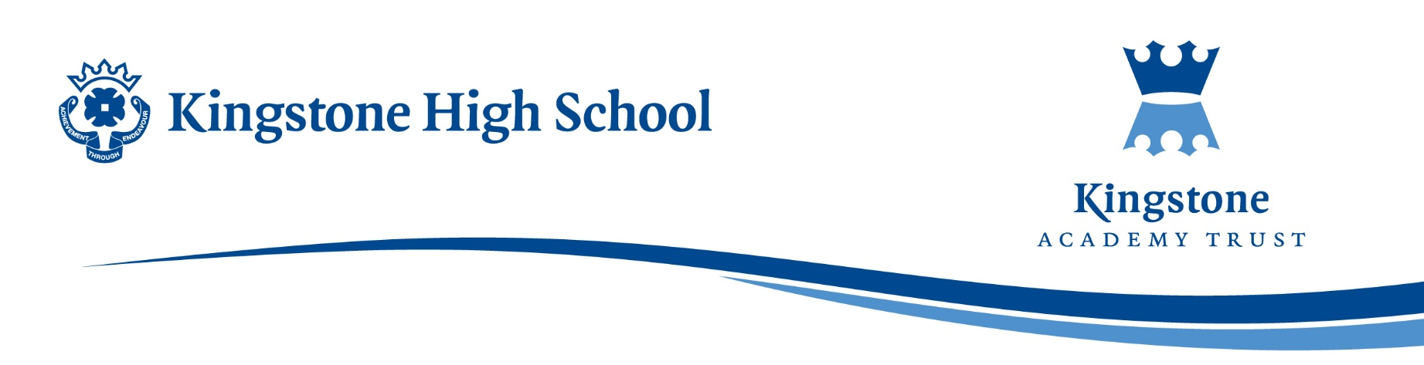

Friday, 12 September 2025

Dear Parent / Carer,

The English Department would like to invite Year 7 students to enjoy a Christmas trip to New Theatre, Cardiff, to watch a pantomime production of Sleeping Beauty on Thursday, 18 December 2025. Tickets have been provisionally booked at a cost of £31.00:

• Return bus journey
• Pantomime ticket for Sleeping Beauty

The departure time will be from school at 09:30am with the return being estimated at 17.30pm. Any student applying for the trip will need to make personal travel arrangements to accommodate the return time.

Assuming that we arrive in Cardiff at a suitable time, students should be able to have lunch at McDonalds which is located near to the theatre. Lunch is not included in the ticket price, so students will need to bring adequate monies for their lunch if they wish to purchase food at this outlet.

Please note that although the trip is open to all students in Year 7, it is paramount that excellent behaviour is maintained whilst off-site. Any student with excessive negative points by Wednesday, 17 December may be removed from the trip. A full refund with be made.

The Finance Department has kindly offered payment to either be in full (£31.00) or in two monthly payments.

- An initial payment of either £31.00 or £15.50 should be made on ParentPay by 15:30pm on Thursday, 25 September 2025.
- The second and final payment of £15.50 to be make on ParentPay by 15:30pm on Friday, 31 October 2025.

Any Free School Meal or Pupil Premium students can be offered financial support. Please contact Mrs Chalk, Finance Office on 01981 250224.

It is important to note that once the application is made and accepted, there will be no refunds at any stage. This means that if a student changes their mind or is absent for any reason on the day of the trip it will not be possible to request a refund.

The closing date for application is Thursday, 25 September 2025.

Yours faithfully,

Miss S Reeves
English Department

