For any queries relating to individual subjects, please email the relevant class teacher or Head of Faculty. If you have any queries relating to assessments or you would like further information regarding Key Assessments, please do not hesitate to email Alex Holmyard at AHolmyard@kingstoneacademy.co.uk.
]

Year 9
Secondary School Key Assessment 1
Timetable and Revision Guidance
9th November 2026 – 20th November 2026
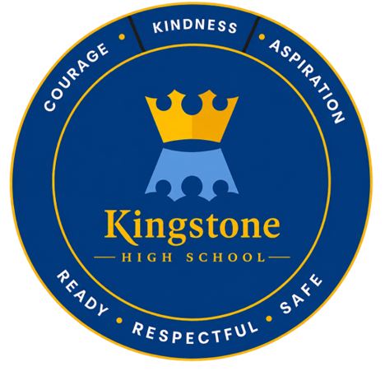

Please find a timetable of when your Key Assessments are taking place for each subject. They are during your timetabled lessons on that day. It is a good idea for you to highlight your particular key assessments.

 | Monday | Tuesday | Wednesday | Thursday | Friday
Period 1 |  | 9A2-Drama  9A1-Art |  | 9B2-Art
Period 2 | 9B2-Drama |  | 9B1-Drama  9A1 - Geography |  | 9B Computer Science  9B- Food & Nutrition Practical
Period 3 |  |  | 9A2-Art | 9A Computer Science  9A- Food & Nutrition Practical | All - Science
Period 4 | Science |  | 9A1-Drama  9B2 - Music | 9B1 – History  9B2 - Geography
Period 5 | En1, En2, En3, En4 & En5 – English | 9A1 – Music  9B1-Art  9A2 - History |  | 9B2 - Music | 9A2 - French  9A1 – French  9B1 – Music  9B2 - History

 | Monday | Tuesday | Wednesday | Thursday | Friday
Period 1 |  | 9B1 – French  9B2 – French  9A1 - RE |  |  | 9B Design & Technology
Period 2 |  | 9B1-Art |  | 9B2-Art  9A1 - History
Period 3 | All - Maths |  | 9B1 – RE  9A2 – Geography
Period 4 |  |  |  |  | 9A Design & Technology
Period 5 |  | 9A2- Art  9B2 – RE  9B1 - Geography | 9A1-Art | 9A2 - RE

Year 9
Key Assessment 1 Revision Guide
Art & Design
Exam Length | 2 Lessons
Topics to Revise  &  Success Criteria | Drawing assessment- each student will complete a still life drawing of a composition of food.  The students will plan and prepare in the lesson before hand to gain feedback and guidance.  The students will be assessed on the key drawing skills they have learnt this half term:  - Quality of painting  - Mixing tints, tones and shades  - Mixing own secondary and tertiary colours
Resources (including useful websites | Your sketchbook – you will be allowed this during the assessment.  Colour - Colour - AQA - GCSE Art and Design Revision - AQA - BBC Bitesize

Year 9
Key Assessment 1 Revision Guide
Computer Science (this is a termly rotation)
Exam Length |  | One lesson
Topics to Revise  &  Success Criteria |  | Python programming:  - Assigning and changing variables  - Using print() and input() functions  - Using selection (if statements) and iteration (while loops)  - Lists and list operations  Introduction to cyber security:  - Protecting personal data  - Types of attack (social engineering, brute force, malware)  - Protecting networks and preventing attacks
Resources (including useful websites |  | Teams workbook  Oak national academy videos and resources  W3schools.com/python  Monday lunchtime coding club (m12)
Year 9
Key Assessment 1 Revision Guide
Design Technology (This is a termly rotation)
Exam Length
Topics to Revise  &  Success Criteria | Making assessment- each student will complete a practical element to show the use of correct tools and safety measures needed to be successful.  The students will be assessed on skills they have learnt this half term, looking at:  . Accuracy  . Quality of finish  . Skill level
Resources (including useful websites

Year 9
Key Assessment 1 Revision Guide
Drama
Exam Length | Each performance is 5 minutes approx
Topics to Revise  &  Success Criteria | Practical assessment- Mask performance.  In groups of 3-4 you will produce a mask performance (title-Love in the park) where you will aim to display your knowledge of the key skills learnt this term.  These include:  - Position on stage (Centre Stage, Grouping)  - Entrances/exits  - Major/ Minoring (Head Turns)  - Centre of weight  - States of emotion  - Whole body  - Stillness
Resources (including useful websites | Mask powerpoint 2024.pptx (sharepoint.com)  Basic Mask Resource Pack.pdf
Year 9
Key Assessment 1 Revision Guide
English
Exam Length | One lesson
Topics to Revise  &  Success Criteria | Gothic Literature  The Key Assessment will feature comprehension questions on the gothic extract.  The main part of the exam will be an extended answer requiring you to give your thoughts and viewpoints on the extract with a key question focus.  Success Criteria  To show your understanding of what you have read through comprehension, identifying key information from a gothic extract.  An extended response that requires your viewpoint and thoughts on how well the writer has achieved their intention in an extract. You should make reference to the following areas: setting, tone, ideas, language, events, structure (STILES) to support your view. You should also use critical adverbs (judgement words) such as effectively, successfully, powerfully . . .
Resources (including useful websites | - Your exercise book  - Gothic Knowledge Organiser  Gothic Horror - Knowledge Organiser - Year 9.pub  - BBC Bitesize  - Gothic literature guide for KS3 English students - BBC Bitesize  - For punctuation and grammar practice:  https://www.bbc.co.uk/bitesize/topics/z4hrt39  https://www.bbc.co.uk/bitesize/topics/zr6bxyc

Year 9
Key Assessment 1 Revision Guide
Food (This is a termly rotation)
Exam Length | 60 mins
Topics to Revise  &  Success Criteria | Practical Assessment  Each student will take part in a practical lesson where they will be assessed on the skills and knowledge developed throughout this half term. During the assessment, students will demonstrate their ability to:  - Work safely and hygienically  - Select and use the correct equipment  - Operate a cooker confidently and correctly  - Apply effective knife skills  - Work at an efficient and consistent pace  - Work independently with minimal guidance
Topics to Revise  &  Success Criteria | Written Assessment  Each student will complete a written assessment to demonstrate their knowledge and understanding of sustainability, ethics, and dietary considerations studied this half term. The assessment will test their ability to explain, analyse, and evaluate these topics. Students will be expected to:  - Explain the concept of carbon footprint and food security, including the impact of food production and transportation on the environment  - Describe the causes and effects of food waste, and evaluate strategies to reduce it  - Discuss the role of food packaging in sustainability, safety, and preservation  - Analyse ethical, moral, and environmental considerations in food choices, including fair trade, animal welfare, and sustainable sourcing  - Explore multicultural foods, including their cultural significance, typical ingredients, and how they contribute to a balanced diet  - Explain how dietary needs change through life stages, including infancy, childhood, adulthood, and older age, and the nutritional considerations for each stage
Resources (including useful websites | Lesson Booklet  Websites:  - BBC Bitesize – Food Preparation & Nutrition  Covers food safety, nutrition, raising agents, sustainability, multicultural foods, and dietary needs: https://www.bbc.co.uk/bitesize  - Food Standards Agency (FSA)  Guidance on food safety, bacteria, hygiene, and food labelling: https://www.food.gov.uk  - NHS Live Well  Nutrition, dietary needs, healthy eating across life stages: https://www.nhs.uk/live-well  - British Nutrition Foundation  Detailed resources on macro/micronutrients, cereals, raising agents, and sustainable diets: https://www.nutrition.org.uk  - WRAP (Waste and Resources Action Programme)  Information on food waste, packaging, and sustainability: https://wrap.org.uk  - Carbon Trust  Explains carbon footprint and environmental impact of food: https://www.carbontrust.com  Videos & Interactive Learning:  - YouTube: CrashCourse Nutrition & Food Safety – Short educational videos on nutrients, food safety, and sustainability  - YouTube: BBC Teach – Clips on multicultural foods, ethical sourcing, and life stage nutrition
Year 9
Key Assessment 1 Revision Guide
French
Exam Length | 30minutes
Topics to Revise  &  Success Criteria | Healthy Eating  Exercise and lifestyle  Using the future tense  Reading and listening assessment  Success criteria  - Understand a simple sentences and longer paragraphs when you read French  - Spell accurately when I transcribe a sentence in French  - Understand a range of positive and negatives opinions in French  - Recognise changes in tense from present to future
Resources (including useful websites | BBC bitesize KS3 French – past and future tense  Year 9 language guide – vocab and structures  www. Quizlet.com - to revise vocabulary on healthy lifestyle
Year 9
Key Assessment 1 Revision Guide
Geography
Exam Length | 55 Mins
Topics to Revise  &  Success Criteria | The assessment will focus on the work we have been doing on Coastal Landscapes of the UK. Topics the assessment will cover include:  - The coastal processes of Erosion, Transportation, Deposition & Weathering  - Features found along the coasts created by Erosion, Deposition and Weathering, such as Archs, Wave Cut Platforms, Spits...  - How the coastline can be managed.  - The use of the Holderness Coast as a case study
Resources (including useful websites | Your main focus for revision should be your exercise book. There are revision guides and websites that can also be used. Please ensure these are for the AQA GCSE Geography course

Year 9
Key Assessment 1 Revision Guide
History
Exam Length | 40 mins
Topics to Revise  &  Success Criteria | 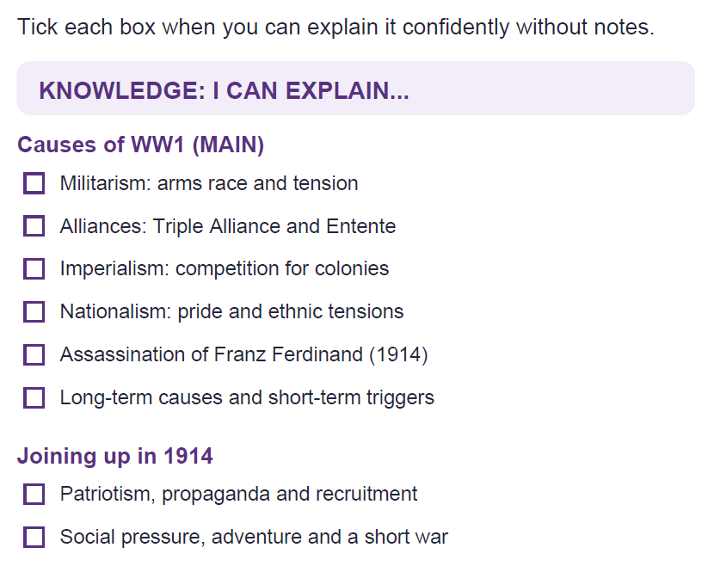  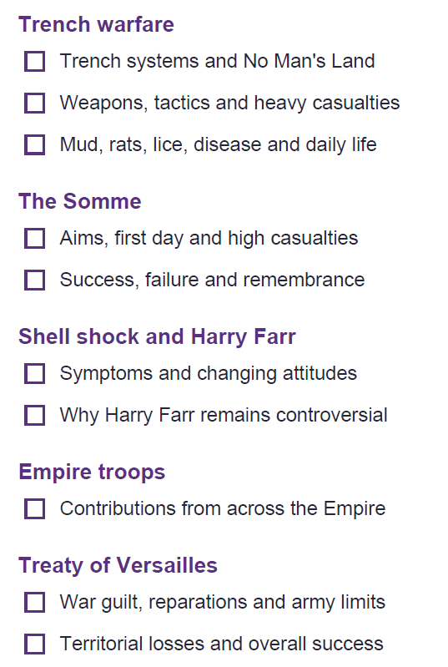  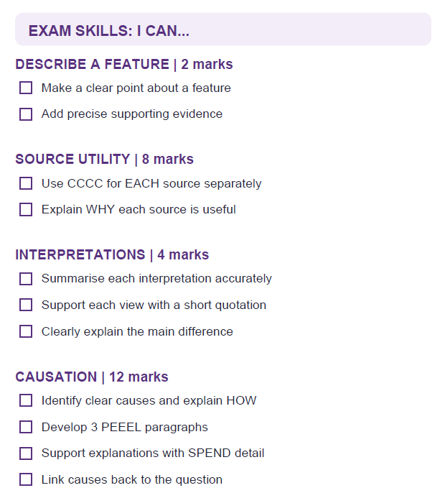  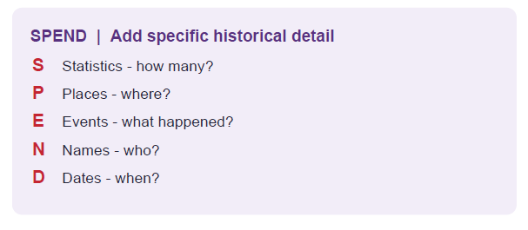  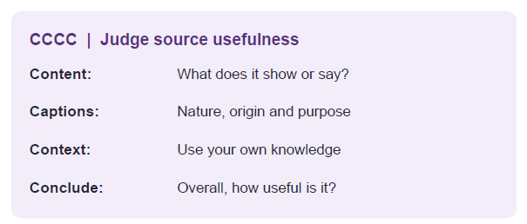
Resources (including useful websites | KO for the topic.
Year 9
Key Assessment 1 Revision Guide
Mathematics
Exam Length | 45mins
Topics to Revise  &  Success Criteria | Calculator allowed  Ordering fractions, decimals and percentages  Fractions of amounts  Percentages of amounts  Increase and decrease by a percentage  Reverse Percentages  Percentage change  Simple interest  Using Expected results  Experimental probabilities  Frequency trees  Standard form (four operations with a calculator)  Solving inequalities - up to unknowns on both sides  Solve double inequalities  Form and solve inequalities  Factorising quadratics  Difference of two squares  Factorise and solve quadratics
Resources (including useful websites | Use your SPARX login to find the video and related support for each topic. Use the guide on the KHS website.  You can also use:  Corbettmaths for extra videos and questions.  ixl.com for explainers and other questions.

Year 9
Key Assessment 1 Revision Guide
Music
Exam Length | 30 minutes
Topics to Revise  &  Success Criteria | You will be completing a 30-minute apprising and listening exam paper, which is structured similarly to how a GCSE written exam takes place.  The first part of the assessment will test your knowledge of Unit 1 – Latin America. Questions will be asked about the information learned in class and contained within the unit presentation (link below).  The second part of the assessment will require you to listen to a piece of Latin American music. You will be asked to comment on the musical elements you hear in that extract.  The broader musical elements will significantly support you. One key area to achieve success is to always link your musical points to the question.
Resources (including useful websites | Unit 1 - Latin America presentation  The Musical Elements explained

Year 9
Key Assessment 1 Revision Guide
Religious Education
Exam Length | 40 minutes
Topics to Revise  &  Success Criteria | 1. Marginalisation  qDefine the term marginalised  qGive examples of marginalised groups  qExplain why Jesus was interested in helping marginalised people  2. The Radical Actions of Jesus  qExplain why Jesus was seen as radical  qDescribe ways Jesus challenged society  qExplain the importance of the Nazareth Manifesto  qExplain what happened in the Temple cleansing  3. Why Was Jesus Crucified?  qExplain why some Jewish leaders opposed Jesus  qExplain why Romans viewed Jesus as a threat  qDefine blasphemy  qDefine treason  4. Radical Christians  YOU HAVE MANY EXAMPLES ON YOUR KNOWLEDGE ORGANISER  qDescribe the work of Martin Luther King Jr  qDescribe the work of Oscar Romero  qExplain how Jesus influenced their actions  5. Street Pastors  qDescribe the work of Street Pastors  qExplain how their work reflects Jesus' teachings  6. Tearfund  qDescribe the work of Tearfund  qExplain how Tearfund's work is influenced by Christian beliefs  7. Sources of Wisdom and Authority  Teachings you should recognise  Nazareth Manifesto  Good news for the poor  Freedom for the oppressed  Love Your Neighbour  Treat everyone with dignity and care  The Good Samaritan  Help those who are in need  Show compassion to outsiders  Cleansing the Temple  Jesus told temple traders they had turned a house of prayer for all nations into a den of thieves. He turned over tables and drove out the traders.  qIdentify teachings linked to justice  qIdentify teachings linked to helping others  qExplain how Christians use Jesus' teachings today
Resources (including useful websites | lesson powerpoints and the KO.  Jesus Nazareth Manifesto film - Teaching With The Chosen: Christ's Sermon in Nazareth, Luke 4:16–30  Jesus overturning tables - https://www.youtube.com/watch?v=rKZiHoSsnfQ  Street Pastors - https://www.youtube.com/watch?v=f1iSRi2lPAc

Year 9
Key Assessment 1 Revision Guide
Science - BIOLOGY
for Combined Science, HIGHER AND FOUNDATION PAPERS
Exam Length | 30 minutes
Topics to Revise  &  Success Criteria | 🔬 Cells & Cell Structure  ☐ Know the functions of:  - Nucleus  - Cytoplasm  - Cell membrane  - Cell wall  - Chloroplast  - Mitochondria  - Vacuole  ☐ Compare plant, animal and bacterial cells  ☐ Know why viruses are not considered living organisms  Revision:  - https://www.bbc.co.uk/bitesize/topics/znyycdm  - https://www.youtube.com/@Cognitoedu  🔍 Microscopes  ☐ Calculate magnification = eyepiece × objective lens  ☐ Know advantages of light and electron microscopes  ☐ Explain how to improve microscope images (staining, thinner samples, higher magnification)  Revision:  - https://www.bbc.co.uk/bitesize/guides/z4whpv4/revision/1  - https://www.youtube.com/@Cognitoedu  🦠 Microorganisms  ☐ Compare bacteria, fungi and viruses  ☐ Know bacterial cell structures ☐ Know the function of a flagellum  Revision:  - https://www.bbc.co.uk/bitesize/topics/z9tbwmn  🌿 Photosynthesis  ☐ Know the role of chlorophyll  ☐ Understand that chlorophyll absorbs light for photosynthesis  Revision:  - https://www.bbc.co.uk/bitesize/topics/zxxmn39  - https://www.youtube.com/@Cognitoedu  🫁 Specialised Cells  ☐ Identify ciliated epithelial cells  ☐ Explain how cilia move mucus and trapped pathogens out of the airways  Revision:  - https://www.bbc.co.uk/bitesize/guides/zvjycdm/revision/1
Resources (including useful websites | Year 8 and Y9 exercise books.  www.seneca.com  www.Educake.co.uk,  Cognito - YouTube

Year 9
Key Assessment 1 Revision Guide
Science - CHEMISTRY
for Combined Science, HIGHER AND FOUNDATION PAPERS
Exam Length | 30 minutes
Topics to Revise  &  Success Criteria | 🌡️ States of Matter  ☐ Know the particle model for solids, liquids and gases  ☐ Name changes of state: melting, freezing, evaporation, condensation  ☐ Explain heating curves and why temperature stays constant during a change of state  Revision:  - https://www.bbc.co.uk/bitesize/topics/zkgg87h  - https://www.youtube.com/@Cognitoedu  🧪 Chromatography  ☐ Explain how chromatography separates mixtures  ☐ Know why the start line is drawn in pencil  ☐ Calculate Rf values  ☐ Interpret chromatograms and identify soluble/insoluble substances  Revision:  - https://www.bbc.co.uk/bitesize/guides/z87qb82/revision/1  - https://www.physicsandmathstutor.com/chemistry-revision/gcse-aqa/separation-techniques/  ⚗️ Acids & Alkalis  ☐ Understand the pH scale  ☐ Know pH 7 is neutral  ☐ Explain neutralisation  ☐ Interpret pH graphs and investigations  Revision:  - https://www.bbc.co.uk/bitesize/topics/zn7tsbk  - https://www.youtube.com/@Cognitoedu  ⚛️ Periodic Table  ☐ Identify metals and non-metals  ☐ Understand groups and periods  ☐ Find elements in the same group  Revision:  - https://www.bbc.co.uk/bitesize/topics/zmxxsbk  - https://www.youtube.com/@Cognitoedu
Resources (including useful websites | Year 8 and Y9 exercise books.  www.seneca.com  www.Educake.co.uk,  Cognito - YouTube

Year 9
Key Assessment 1 Revision Guide
Science - PHYSICS
for Combined Science, HIGHER AND FOUNDATION PAPERS
Exam Length | 30 minutes
Topics to Revise  &  Success Criteria | ⚡ Energy Changes & Efficiency  ☐ Describe energy transfers between kinetic, gravitational potential and thermal energy stores.  ☐ Explain the energy changes when an object is thrown upwards and falls back down.  ☐ Calculate wasted energy.  ☐ Calculate efficiency = useful output ÷ total input.  Revision:  - https://www.bbc.co.uk/bitesize/topics/z4brd2p  - https://www.youtube.com/@Cognitoedu  - https://www.physicsandmathstutor.com/physics-revision/gcse-aqa/energy/  🔌 Electricity  ☐ Use V = I × R.  ☐ Calculate current using I = V ÷ R.  ☐ Know that copper wires have very low resistance.  ☐ Identify and draw an ammeter in series.  ☐ Know that components in parallel have the same voltage.  Revision:  - https://www.bbc.co.uk/bitesize/topics/zk4cwmn  - https://www.youtube.com/@Cognitoedu  - https://www.physicsandmathstutor.com/physics-revision/gcse-aqa/electricity/  🚢 Forces  ☐ Calculate weight using W = m × g.  ☐ Know Earth's gravitational field strength is approximately 10 N/kg.  ☐ Understand the difference between mass (kg) and weight (N).  ☐ Identify weight and upthrust forces on floating objects.  Revision:  - https://www.bbc.co.uk/bitesize/topics/zkgg87h  - https://www.youtube.com/@Cognitoedu  🌊 Waves & Sound  ☐ Explain how frequency affects pitch.  ☐ Explain how amplitude affects loudness.  ☐ Compare two sound wave diagrams.  Revision:  - https://www.bbc.co.uk/bitesize/topics/zgffr82  - https://www.physicsandmathstutor.com/physics-revision/gcse-aqa/waves/  🔥 Heating & Insulation  ☐ Explain how foam insulation reduces heat transfer.  ☐ Describe conduction and convection.  ☐ Explain why trapped air is an effective insulator.  Revision:  - https://www.bbc.co.uk/bitesize/topics/z8bbb9q  - https://www.youtube.com/@Cognitoedu
Resources (including useful websites | Year 8 and Y9 exercise books.  www.seneca.com  www.Educake.co.uk,  Cognito - YouTube

