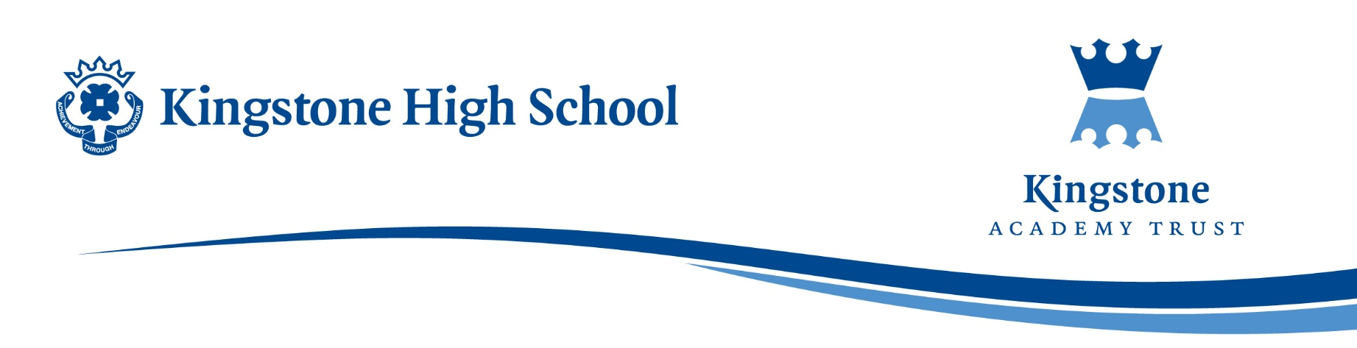

Date: 24/10/2025

Dear Parents and Carers,

Year 8 Reward Trip – Information Letter

We are delighted to inform you that arrangements are underway for a Year 8 Reward Trip, which will take place at the end of the next half-term.

The trip will be an opportunity to celebrate and reward students who have consistently demonstrated a positive attitude, excellent behaviour, and commitment to the school’s values.

Further details regarding the location, date, cost, and itinerary of the trip will be shared with you in due course.

Eligibility Criteria for the Reward Trip

It has been agreed that the criteria for all reward trips will be based on a positive-to-negative behaviour ratio, monitored over a 5-week period leading up to the trip, starting from the beginning of the next half-term.

To qualify for the trip, students must have at least 80% of their total behaviour points recorded as positive.

This means:

- If a student’s negative points account for more than 20% of their overall total, they will not be eligible to attend the reward trip.

- The calculation will be based on all positive and negative behaviour points recorded during the 5-week monitoring period.

This system ensures fairness and consistency across the year group, rewarding those who make a sustained effort to maintain positive behaviour and demonstrate the values expected at Kingstone High School.

We are very much looking forward to celebrating the achievements of our students with this exciting trip. Further details will be communicated in due course.

Thank you for your continued support in encouraging your child to make positive choices both in and out of the classroom.

Yours faithfully

Mr D. Bromage
Director of Studies (Year 8 and Year 9)

