For any queries relating to individual subjects, please email the relevant class teacher or Head of Faculty. If you have any queries relating to assessments or you would like further information regarding Key Assessments, please do not hesitate to email Alex Holmyard at AHolmyard@kingstoneacademy.co.uk.
]

Year 8
Secondary School Key Assessment 1
Timetable and Revision Guidance
9th November 2026 –20TH November 2026



Please find a timetable of when your Key Assessments are taking place for each subject. They are during your timetabled lessons on that day. It is a good idea for you to highlight your particular key assessments.
 | Monday | Tuesday | Wednesday | Thursday | Friday
Period 1 |  |  | 8A Design & Technology |  | 8B1- Art
Period 2 |  | 8A2 – French  8A1 - Art | En3 – English | 8B Design & Technology
Period 3 |  | 8A- Food & Nutrition Practical | 8A2 – Music  8B2- Art | All - Science | 8B- Food & Nutrition Practical
Period 4 | En1, En2 & EN4 – English | 8B2 - Music |  |  | 8B2 – French  8A2- Art
Period 5

 | Monday | Tuesday | Wednesday | Thursday | Friday
Period 1 |  | 8B2 - Art  8B1 – Music  8A1 - History | 8B1 – Drama  8A1 – RE  8A2 - RE | 8A2 Geography  8B2 - Geography
Period 2 | 8A2-Drama  8B1- French  8A1 - Geography | All - Maths | 8A1-Art  8B1 - Geography | 8B1-Art
Period 3 | 8A Computer Science | 8A1-Drama  8A2- Art  8B2 – RE |  | 8B Computer Science
Period 4 |  | 8B2 - History |  |  | 8B1 - RE
Period 5 | 8B2-Drama  8A1 – French  8B1 – History  8A2 - History

Year 8
Key Assessment 1 Revision Guide
Art & Design
Exam Length | 2 Lessons
Topics to Revise  &  Success Criteria | Practical ceramic assessment based on the work of Heather Knight and their own design ideas inspired by natural forms. Students will have completed a test 2D piece prior to the assessment.  The students will be assessed on the key ceramic skills they have learnt this half term:  - Adding a range of applied and incised textures  - Quality of construction  - Quality of design inspired by natural textures
Resources (including useful websites | Your sketchbook – you will be allowed this during the assessment.  KHS Drawing Revision Guide.pptx

Year 8
Key Assessment 1 Revision Guide
Computer Science (this is a termly rotation)
Exam Length | One lesson
Topics to Revise  &  Success Criteria | Python programming:  - Assigning and changing variables  - Using print() and input() functions  - Using selection (if statements) and iteration (while loops)  Computer systems and data science:  - Computer architecture  - Operating Systems  - Boolean logic including logic gates  - Machine learning and AI
Resources (including useful websites | Teams workbook  Oak national academy videos and resources  W3schools.com/python  Monday lunchtime coding club (m12)

Year 8
Key Assessment 1 Revision Guide
Design Technology (This is a termly rotation)
Exam Length
Topics to Revise  &  Success Criteria | Making assessment- each student will complete a practical element to show the use of correct tools and safety measures needed to be successful.  The students will be assessed on skills they have learnt this half term, looking at:  . Accuracy  . Quality of finish  . Skill level
Resources (including useful websites

Year 8
Key Assessment 1 Revision Guide
Drama
Exam Length | Each performance will be 5 minutes in length (approx)
Topics to Revise  &  Success Criteria | Practical assessment- Characterisation seven deadly sins performance.  In groups of 5-7 you will devise your own storyline based on the characters of the 7 deadly sins. You will aim to display your knowledge of the key skills learnt this term. These include  - ^{Facial Expression}  - ^{Voice}  - ^{Gesture}  - ^{Body language}  - ^{Posture}  ^{Pace/speed}
Resources (including useful websites | characterisation powerpoint-updated 24.pptx (sharepoint.com)

Year 8
Key Assessment 1 Revision Guide
English
Exam Length | One lesson
Topics to Revise  &  Success Criteria | ‘Animal Farm’ by George Orwell  The Key Assessment will feature a quiz recapping your knowledge of the text, ‘Animal Farm’. The main part of the exam will be an extended answer on a character from the text.  Success Criteria  - Make a clear point using the words from the question  - Used evidence from the text to support your point  - Explained what the evidence suggests  - Use Orwell’s name in your answer  - Mention how the reader reacts  - Accurate use of SPaG  - Make use of keywords including tyrant, manipulator, cruel
Resources (including useful websites | - Your exercise book  - ‘Animal Farm’ Knowledge Organiser  Animal Farm - Knowledge Organiser.pub  - BBC Bitesize  Animal Farm by George Orwell - BBC Bitesize  - For punctuation and grammar practice:  https://www.bbc.co.uk/bitesize/topics/z4hrt39  https://www.bbc.co.uk/bitesize/topics/zr6bxyc

Year 8
Key Assessment 1 Revision Guide
Food (This is a termly rotation)
Exam Length | 60 minutes
Topics to Revise  &  Success Criteria | Practical Assessment  Each student will take part in a practical lesson where they will be assessed on the skills and knowledge developed throughout this half term. During the assessment, students will demonstrate their ability to:  - Work safely and hygienically  - Select and use the correct equipment  - Operate a cooker confidently and correctly  - Apply effective knife skills  - Work at an efficient and consistent pace  - Work independently with minimal guidance
Topics to Revise  &  Success Criteria | Written Assessment  Each student will complete a written assessment to demonstrate their knowledge and understanding of food safety, nutrition, and key ingredients studied this half term. The assessment will test their ability to explain, apply, and evaluate these topics. Students will be expected to:  - Explain how food safety practices prevent contamination and foodborne illness  - Describe the role of bacteria in food spoilage and illness, and how their growth can be controlled  - Distinguish between macro nutrients (carbohydrates, proteins, fats) and micronutrients (vitamins and minerals), explaining their functions in the body  - Identify the importance of cereals in the diet, including their nutritional value and uses in food preparation  - Identify and explain the labelling and grading of eggs, including the information shown on egg, as well as describing different methods of cooking eggs and functions of eggs in cooking.  - Describe the nutritional value of fish, including protein, omega-3 fatty acids, vitamins and minerals, and explain different methods of preparing and cooking fish  - Explain the functions of sugar in food preparation, including sweetness, colouring, preservation, texture, fermentation, and its role in baking  - Explain gelatinisation, including how starch absorbs liquid and swells when heated, and identify foods where gelatinisation occurs  - Describe the different methods of heat transfer — conduction, convection and radiation — and explain how they are used in cooking  - Describe different types of raising agents (biological, chemical, mechanical, steam) and explain how they work in cooking and baking
Resources (including useful websites | Lesson Booklet  Knowledge organisers  Websites:  - BBC Bitesize – Food Preparation & Nutrition  Covers food safety, nutrition, raising agents, sustainability, multicultural foods, and dietary needs: https://www.bbc.co.uk/bitesize  - Food Standards Agency (FSA)  Guidance on food safety, bacteria, hygiene, and food labelling: https://www.food.gov.uk  - NHS Live Well  Nutrition, dietary needs, healthy eating across life stages: https://www.nhs.uk/live-well  - British Nutrition Foundation  Detailed resources on macro/micronutrients, cereals, raising agents, and sustainable diets: https://www.nutrition.org.uk  Videos & Interactive Learning:  - YouTube: CrashCourse Nutrition & Food Safety – Short educational videos on nutrients, food safety, and sustainability

Year 8
Key Assessment 1 Revision Guide
French
Exam Length | 30 mins
Topics to Revise  &  Success Criteria | TV programmes and film vocabulary  Giving opinions and justify your views  Talking about what you do online  Using the perfect tense to talk about what you have done in the past  Success Criteria  - Show you can understand short sentences and paragraphs using the vocabulary from this topic in reading and listening tasks  - Show you can understand opinions – positive and negative  - Show you can understand two different time frames – past and present
Resources (including useful websites | Year 8 language guide – all students have one  Key questions from this terms work  BBC bitesize  Quizlet – to revise key vocabulary  www.languagesonline.org.uk - to revise the perfect tense and vocabulary

Year 8
Key Assessment 1 Revision Guide
Geography
Exam Length | 55 Mins
Topics to Revise  &  Success Criteria | The focus of this assessment will be on the work we have been doing this half term on Volcanoes and whether they are a blessing or a curse: Topics covered include:  - The structure of the earth including the different layers  - The main continents and tectonic plates  - The distribution of volcanoes  - The different types of plate boundary  - The effects of the Montserrat and Iceland volcanoes, including how and why they differ  - Why some people live near volcanoes  - What can living near people do – The 3Ps of Prediction, Protection and Planning
Resources (including useful websites | Your main focus for revision should be your exercise book

Year 8
Key Assessment 1 Revision Guide
History
Exam Length | 40 minutes
Topics to Revise  &  Success Criteria | The beliefs of James I about kingship, witches and religion.  The Causes of the English Civil War  Success Criteria  Source Analysis:  - Content: describe two things learned from the content and related it to usefulness  - Caption: Provenance – describe two things that the provenance (in the caption) has told me and how it related to usefulness  - Context: Own Knowledge: explain something I already know about the topic and referenced it to the source (context). I have commented on the usefulness of this. Written lots of accurate historical information that is relevant to the enquiry topic.  - Conclusion – a clear statement on the overall usefulness, of the source.  Narrative:  - A well-developed narrative that organises material into a sequence (correct order) of events that ends with the results of the event.  - The account of events analyses the links between them and is clearly and logically structured  - Includes accurate and relevant information, showing excellent knowledge and understanding of the key features of the events.  - All key words are used correctly  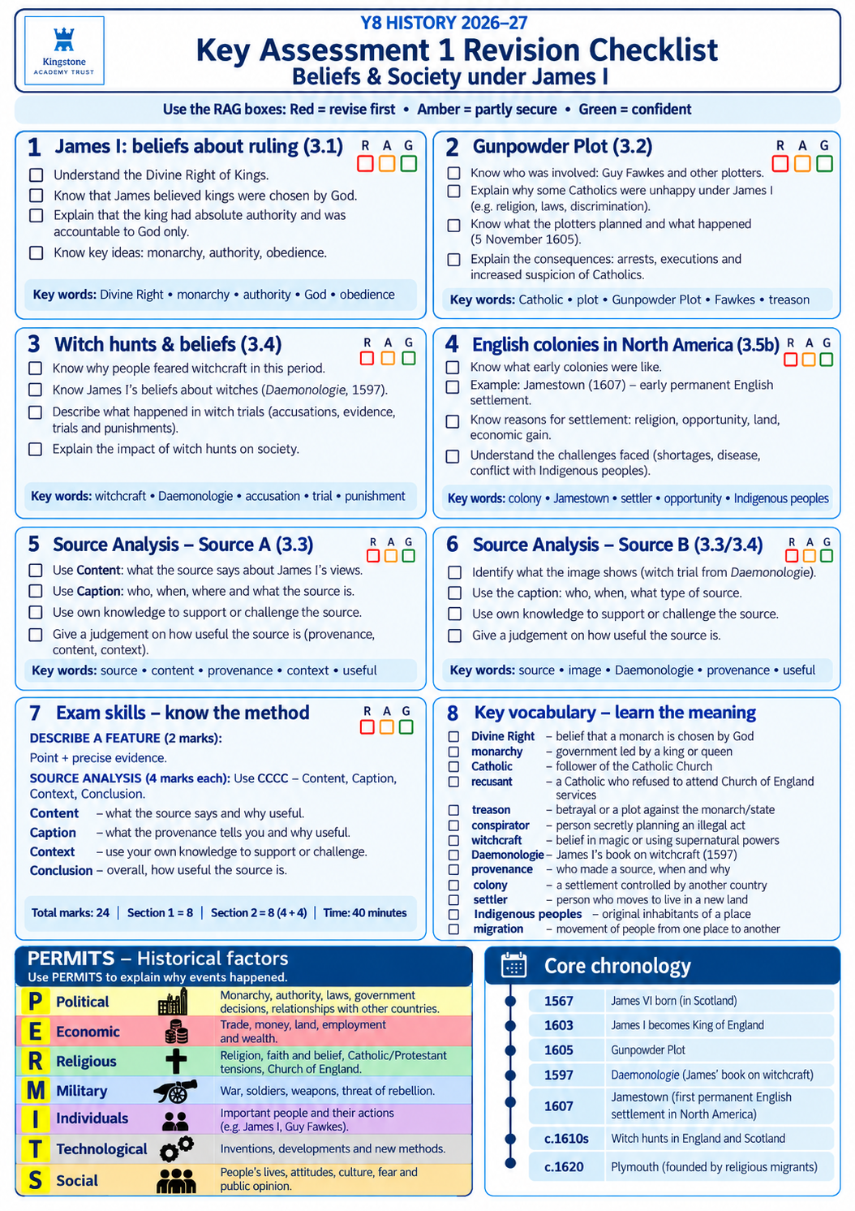
Resources (including useful websites | knowledge organisers and text book pages.

Year 8
Key Assessment 1 Revision Guide
Mathematics
Exam Length | 45mins
Topics to Revise  &  Success Criteria | Calculator allowed  Index Laws  Simplifying Expressions: multiplication and division  Solve One Step Equation: addition and multiplication  Solve Two Step Equations  Solve Three Step Equation  Solve Equations with Unknowns Both Sides  Solve Complex Equations  Calculate Percentage of Amounts  State Multiplier: Increase and decrease  Calculate Percentage of Amounts  Problem Solving: Scaling  Direct Proportion  Best Buys
Resources (including useful websites | Use your SPARX login to find the video and related support for each topic. Use the guide on the KHS website.  You can also use:  Corbettmaths for extra videos and questions.  ixl.com for explainers and other questions.

Year 8
Key Assessment 1 Revision Guide
Science
Exam Length | 40 minutes
Topics to Revise  &  Success Criteria | 🔬 Cells  ☐ Know the functions of nucleus, cytoplasm, cell membrane, mitochondria, chloroplast, vacuole and cell wall  ☐ Compare plant and animal cells  Revision:  - https://www.bbc.co.uk/bitesize/topics/znyycdm  - https://www.youtube.com/@Cognitoedu  🌡️ Particles & States of Matter  ☐ Describe solids, liquids and gases  ☐ Know melting, freezing, boiling and condensation  ☐ Explain pressure in gases using particles  Revision:  - https://www.bbc.co.uk/bitesize/topics/zkgg87h  - https://www.youtube.com/@Cognitoedu  ⚛️ Elements, Compounds & Mixtures  ☐ Identify elements, compounds and mixtures from particle diagrams  ☐ Know that air is a mixture containing oxygen and other gases  Revision:  - https://www.bbc.co.uk/bitesize/topics/zsttq6f  - https://www.youtube.com/@Cognitoedu  ⚡ Energy  ☐ Know gravitational potential, kinetic and elastic energy stores  ☐ Describe energy transfers in a bungee jump  ☐ Explain energy transfers in a hydroelectric power station  ☐ State the Law of Conservation of Energy  Revision:  - https://www.bbc.co.uk/bitesize/topics/z4brd2p  - https://www.youtube.com/@Cognitoedu  ⛽ Fuels  ☐ Know examples of fossil fuels (coal, oil, natural gas)  ☐ Know fossil fuels formed millions of years ago  ☐ Identify renewable and non-renewable fuels  Revision:  - https://www.bbc.co.uk/bitesize/topics/zx3939q  🚗 Speed  ☐ Use: Speed = Distance ÷ Time  ☐ Calculate average speed  Revision:  - https://www.bbc.co.uk/bitesize/topics/zwwb7p3  🧪 Working Scientifically  ☐ Identify independent, dependent and control variables  ☐ Read graphs and tables  ☐ Identify anomalies  ☐ Draw a line of best fit  ☐ Make predictions from graphs  ☐ Suggest improvements to reliability  Revision:  - https://www.bbc.co.uk/bitesize/topics/zw7fwmn
Resources (including useful websites | Year 7 and Y8 exercise books.  www.seneca.com,  www.Educake.co.uk,  Cognito - YouTube

Year 8
Key Assessment 1 Revision Guide
Music
Exam Length | Rehearse for 3 weeks and then a 2-minute-long performance
Topics to Revise  &  Success Criteria | Practical assessment – Performance  You will need to perform the 12 Bar Blues on the keyboard.  Keyboard: You will need to perform the 12 Bar Blues  Melody for the basic part, the melody and accompaniment as an intermediate part and the melody, accompaniment and bass line with two hands for the advanced part. Students playing other instruments like guitars, bass and drums will be assessed separate to the keyboards.  You will be assessed on how accurate, fluent and steady your performance is. You should keep the beat steady. Notes must all be accurate and played together with the ensemble.
Resources (including useful websites | Unit 1 - Jazz Presentation  Virtual Piano

Year 8
Key Assessment 1 Revision Guide
Religious Education
Exam Length | 40 minutes
Topics to Revise  &  Success Criteria | What does Creation teach about being human?  You should know:  Key events in Genesis 1 & 2.  qWhat Genesis teaches about God.  qWhat Genesis teaches about humans.  qWhy humans are described as special.  qWhy humans are given responsibilities.  qWhat Christians learn from the Creation stories.  Key ideas: Creation, Genesis, Imago Dei  Belief in Imago Dei  (Made in Image of God)  qTo have value and dignity.  qTo be different from animals  qGod’s own breath – a soul  qPARTNERS with God (relationship)  qPROVISION from God (blessings)  qPROTECTED by God (Cared for)  qGiven PURPOSE by God (roles in creation)  Key ideas: Imago Dei, dignity, relationship, purpose  Dominion and Stewardship  qWhat dominion means.  qWhat stewardship means.  qSimilarities and differences between the two ideas.  qWhy some Christians think dominion can be misunderstood.  qHow The Fall relates to human behaviour.  qWhy responsibility is important in Creation.  Key ideas: Dominion, Stewardship, The Fall, responsibility, exploit  Stewardship in Action  qWays Christians care for Creation.  qExamples of stewardship today.  qWhat Eco Church is.  qWhat Fairtrade is.  qWhy some Christians choose environmentally-friendly lifestyles.  Key ideas: Eco Church, Fairtrade, sustainable  Creation as Evidence for God  qPaul's argument about Creation.  qWhy Christians believe Creation points to a Creator.  qThe idea of Intelligent Design.  qExamples used to support Intelligent Design.  qResponses – faith and worship  Key ideas: Paul, Romans 1, Intelligent Design, fine tuning, irreducible complexity  Humanist Views  qWhat Humanists believe.  qWhy Humanists are atheists.  qThe theory of evolution.  qWhy Humanists still believe people should care for the world.  Key ideas: Humanism, evolution, science, responsibility  Key Sources of Authority  You should be familiar with:  qGenesis 1:26-28  qGenesis 2:15  qGenesis 1:27  qPsalm 24:1 (The earth is the Lord’s)  qRomans 1:20  You do not need to memorise every word, but you should know what each source teaches.  ✅ General Exam Skills  ✅ To improve your answers:  •☐ Use key words from each topic  •☐ Give more than one idea  •☐ Explain your points (not just list them)  •☐ Link beliefs to real-life actions  ✅ Final check before the exam  •☐ I can explain key religious ideas in my own words  •☐ I can give examples of beliefs and actions  •☐ I can think about different viewpoints  ☐ I can write a clear conclusion when needed
Resources (including useful websites | Genesis 1-2 NIV - The Beginning - In the beginning God - Bible Gateway The Bible chapters.  Chris Tomlin - Indescribable (Lyrics) (youtube.com) Worship song based on the belief in a creator God.  Christianity - issues of life and death - Eduqas - BBC Bitesize some sections in this page – the origins of the universe and the origins of human life.

