For any queries relating to individual subjects, please email the relevant class teacher or Head of Faculty. If you have any queries relating to assessments or you would like further information regarding Key Assessments, please do not hesitate to email Alex Holmyard at AHolmyard@kingstoneacademy.co.uk.
]

Year 7
Secondary School Key Assessment 1
Timetable and Revision Guidance
9th November 2026 – 20th November 2026


Please find a timetable of when your Key Assessments are taking place for each subject. They are during your timetabled lessons on that day. It is a good idea for you to highlight your particular key assessments.
 | Monday | Tuesday | Wednesday | Thursday | Friday
Period 1 |  | 7AF English | 7AF - History |  | 7A2-Drama  7NP – History
Period 2 | 7NP English | 7MH English | 7NS English |  | 7A1 – French
Period 3 |  | 7A2 – Music  7NS - History | 7B-Food & Nutrition Practical | 7B2-Drama | 7B1 – French  7MH – History  7AF - Geography
Period 4 | 7A1 - Music |  | 7A-Food & Nutrition Practical
Period 5

 | Monday | Tuesday | Wednesday | Thursday | Friday
Period 1 |  |  | 7NP and 7AF Science | 7A Computer Science
Period 2 | 7A2 French |  | 7B Design & Technology  7B Computer Science
Period 3 |  | 7NS – Music  7NP - Geography | 7A Design & Technology | 7NS – Geography  7AF - RE | 7B1-Drama  7AF & 7NP Maths
Period 4 | 7B2 French  7MH - Music | 7A1-Drama | 7MH – RE  7NP - RE | 7MH Geography | 7NS & 7MH Maths
Period 5 |  | 7NS - RE | 7NS and 7MH science

Year 7
Key Assessment 1 Revision Guide

Art & Design
Exam Length | Two lessons
Topics to Revise  &  Success Criteria | Practical painting assessment focusing on painting skills learnt in the lesson.  Success criteria  - Quality of handling the painting materials  - Mixing own paint colours – secondary and tertiary colours  - Adding tints and shades  - Design inspired by our chosen artist.
Resources (including useful websites | Your sketchbook – you will be allowed this in the assessment  Colour - Colour - AQA - GCSE Art and Design Revision - AQA - BBC Bitesize

Year 7
Key Assessment 1 Revision Guide
Computer Science (this is a termly rotation)
Exam Length | One lesson
Topics to Revise  &  Success Criteria | Scratch programming:  - Sequencing commands including subroutines  - Variables  - Using selection (if and else blocks)  - Comparison and logic operators  - Using iteration (repeat blocks)  Clear messaging in digital media:  - Features of a poster  - Slide decks  - Reviewing digital products
Resources (including useful websites | Teams workbook  Oak national academy videos and resources  scratch.mit.edu  Monday lunchtime coding club (m12)

Year 7
Key Assessment 1 Revision Guide

Design Technology (This is a termly rotation)
Exam Length | One lesson
Topics to Revise  &  Success Criteria | Making assessment- each student will complete a practical element to show the use of correct tools and safety measures needed to be successful.  The students will be assessed on skills they have learnt this half term, looking at:  . Accuracy  . Quality of finish  . Skill level
Resources (including useful websites

Year 7
Key Assessment 1 Revision Guide

Drama
Exam Length | Each performance is 5 minutes long (approx..)
Topics to Revise  &  Success Criteria | Practical assessment- Status performance.  In pairs you will rehearse and perform the complete Chris and Tammy scene. You will aim to display your knowledge of the key skills learnt this term. These include  - Powerhouse  - Levels  - Voice  - Staging
Resources (including useful websites | Status - Year 7.ppt1 2024.pptx (sharepoint.com)

Year 7
Key Assessment 1 Revision Guide
English
Exam Length | One lesson
Topics to Revise  &  Success Criteria | Legendary Heroes - Beowulf  The Key Assessment will feature a quiz recapping your knowledge of skills and context. The main part of the exam will be an extended answer on a character from the text.  Success Criteria  - Make a clear point using the words from the question  - Used evidence from the text to support your point  - Explained what the evidence suggests  - Use the character’s name in every paragraph  - Mention how the reader reacts  - Accurate use of SPaG  - Make use of keywords including: Legendary, heroic, protagonist, antagonist
Resources (including useful websites | - Your exercise book  - Beowulf plot summary  KS2 English: Beowulf - BBC Teach  - For punctuation and grammar practice:  https://www.bbc.co.uk/bitesize/topics/z4hrt39  https://www.bbc.co.uk/bitesize/topics/zr6bxyc

Year 7
Key Assessment 1 Revision Guide

Food (This is a termly rotation)
Exam Length | 60 minutes
Topics to Revise  &  Success Criteria | Practical Assessment  Each student will take part in a practical lesson where they will be assessed on the skills and knowledge developed throughout this half term. During the assessment, students will demonstrate their ability to:  - Work safely and hygienically  - Select and use the correct equipment  - Operate a cooker confidently and correctly  - Apply effective knife skills  - Work at an efficient and consistent pace  - Work independently with minimal guidance
Topics to Revise  &  Success Criteria | Written Assessment  Each student will complete a written assessment to demonstrate their understanding of the key topics studied this half term. The assessment will test both knowledge and the ability to apply learning in different contexts. Students will be expected to:  - Explain the importance of personal hygiene in food preparation and its role in preventing contamination  - Identify and apply key principles of health and safety in the kitchen  - Describe how bacteria grow and spread, and outline effective methods of ensuring food safety  - Use the Eatwell Guide to show understanding of a balanced diet and healthy eating choices  - Discuss the role of vitamins and minerals in maintaining health and wellbeing  - Evaluate the impact of fats in the diet, considering both positive functions and potential health risks.
Resources (including useful websites | Lesson Booklet  Knowledge organisers  Websites:  - NHS Live Well – Guidance on healthy eating, nutrition, and the Eatwell Guide: www.nhs.uk/live-well  - Food Standards Agency (FSA) – Information on food hygiene, safety, and bacteria: www.food.gov.uk  - BBC Bitesize (Food Technology/Nutrition) – Student-friendly revision materials on health, hygiene, nutrition, and cooking skills: www.bbc.co.uk/bitesize  Videos & Interactive Resources:  - YouTube: NHS Choices – Short videos on healthy eating, food safety, and hygiene  - British Nutrition Foundation – Educational resources and fact sheets on nutrients, fats, vitamins, and minerals: www.nutrition.org.uk

Year 7
Key Assessment 1 Revision Guide

French
Exam Length | 30 minutes
Topics to Revise  &  Success Criteria | This assessment will focus on:  Giving opinions – saying what I like, love, dislike and hate  Talking about my free time and sports  I will complete a reading and listening assessment  - I can recognise single words in French  - I can understand a simple sentence in French  - I can transcribe single words/short phrases correctly  - I can write single words/ simple phrases correctly in French
Resources (including useful websites | www.quizlet.com to learn and revise vocabulary  BBC bitesize KS3 French for reading and listening revision  Year 7 language guide – each student has one

Year 7
Key Assessment 1 Revision Guide

Geography
Exam Length | 55 Mins
Topics to Revise  &  Success Criteria | The assessment will focus on the work we have been doing during this half term. This will include:  - What is Geography? – Human & Physical  - The Geography of the UK  - Population Distribution in the UK and reasons to explain the distribution  - Farm Distribution in the UK  - Rainfall patterns in the UK and reasons for the variations  - How and why the UK population has changed over time  - How migration can affect population
Resources (including useful websites | Your main focus for revision should be your Geography Exercise Book

Year 7
Key Assessment 1 Revision Guide

History
Exam Length | 40 minutes
Topics to Revise  &  Success Criteria | The assessment will focus on Anglo-Saxon and Norman England.  Success Criteria:  There will be knowledge questions to assess how much of the key content has been absorbed and remembered.  Narrative – telling events in chronological order.  Causation – explaining the different reasons why an even happened  Description:  - A detailed description of a key feature  - Lots of SPEND knowledge included (statistics, places, events, names and dates)  - Includes accurate and relevant information, showing excellent knowledge and understanding of the key features of the events.  - All key words are used correctly  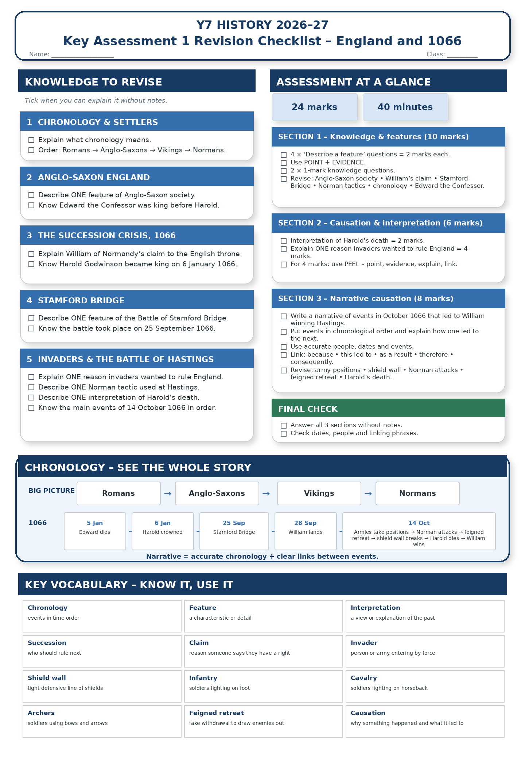
Resources (including useful websites | Please use your knowledge organisers in your exercise books (at back of book)

Year 7
Key Assessment 1 Revision Guide

Mathematics
Exam Length | 45mins
Topics to Revise  &  Success Criteria | Non-Calculator  Place value in integers  Comparing numbers with inequalities  Writing numbers in order  Rounding to the nearest 1000  Rounding to decimal places  Integers - addition and subtraction, multiplication and division  Decimals - addition and subtraction, multiplication and division  Writing negative numbers in order  Directed number - addition and subtraction, multiplication and division  BIDMAS  Simplifying algebra: multiplication, addition and division  Collecting like terms  Collecting like terms with different powers  Solve one step equations: addition, subtraction, multiplication and division  Solve two step equations  Substitute into formulae
Resources (including useful websites | Use your SPARX login to find the video and related support for each topic. Use the guide on the KHS website.  You can also use:  Corbettmaths for extra videos and questions.  ixl.com for explainers and other questions.

Year 7
Key Assessment 1 Revision Guide
Music
Exam Length | 3 weeks rehearsing with 15 minutes to perform, record and assess
Topics to Revise  &  Success Criteria | Performing Assessment  As part of Unit 1 – The Musical Elements, students will learn to play a part in a class ensemble. Students will spend 3 weeks rehearsing Beethoven’s Ode to Joy, before the final performance, recording and assessment. The assessment will take place during Key Assessment week in lesson time. Students will learn the piece in class, however they are welcome to practice at home if they would like and have relevant musical instruments. They could also use online keyboards using the internet. The Unit presentation, which contains the music can be found below.
Resources (including useful websites | Unit 1 - The Musical Elements Presentation  Virtual Piano

Year 7
Key Assessment 1 Revision Guide
Science
Exam Length | 40 minutes
Topics to Revise  &  Success Criteria | 🔥 Lab Equipment  ☐ Label a Bunsen burner  ☐ Identify:  - Beaker  - Test tube  - Thermometer  - Measuring cylinder  - Conical flask  - Tripod  - Gauze  - Filter funnel  Revision:  - https://www.bbc.co.uk/bitesize/topics/z7xxsbk  - https://www.youtube.com/@Cognitoedu  🐭 Life Processes  ☐ Know the 7 life processes (MRS GREN)  ☐ Explain how living things differ from non-living things  Revision:  - https://www.bbc.co.uk/bitesize/topics/z6882hv  🫁 Human Body  ☐ Know the function of the urinary system  ☐ Know the role of the kidneys  Revision:  - https://www.bbc.co.uk/bitesize/topics/zvhhvcw  🔬 Scientific Investigations  ☐ Identify independent, dependent and control variables  ☐ Read graphs and tables  ☐ Explain whether results support a prediction  ☐ Describe a fair test  Revision:  - https://www.bbc.co.uk/bitesize/topics/zw7fwmn  🧪 Solubility  ☐ Read and interpret solubility graphs  ☐ Compare the solubility of substances at different temperatures  ☐ Explain how temperature affects solubility  Revision:  - https://www.bbc.co.uk/bitesize/topics/zsttq6f
Resources (including useful websites | Year 7 exercise books.

