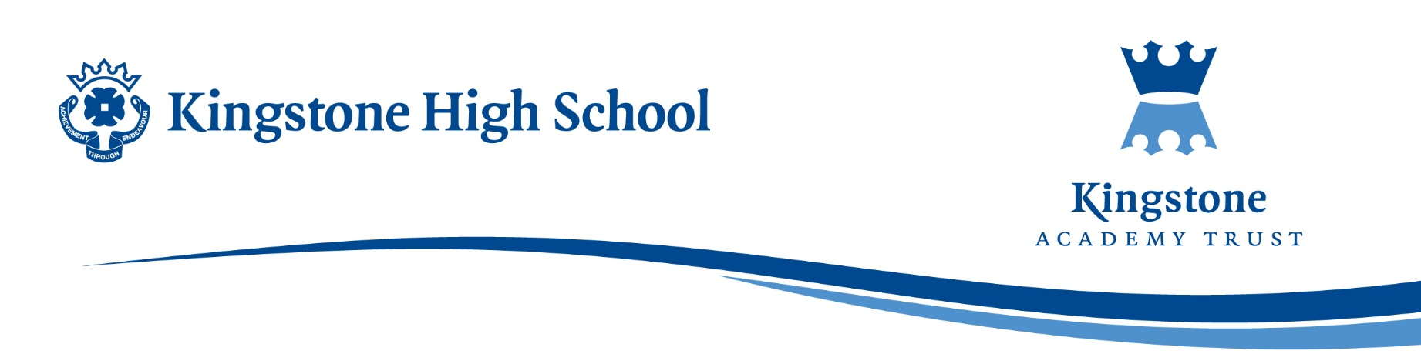

Subject: Upcoming Mock Examinations
Dear Parents/Carers,
We are approaching our mock examination period, which is a crucial step in preparing your child for their final GCSE examinations next year. Please find attached the examination timetable, outlining the dates and times for all assessments during this mock window.
Mock examinations play a vital role in students’ preparation. They provide an opportunity to practise working under formal exam conditions, helping students to build confidence and develop effective time management skills. They also enable students to identify their strengths and areas requiring further revision, allowing for more focused and productive study.
The results from these exams are equally important for staff. They allow teachers to accurately assess each student’s progress and tailor teaching and support accordingly. Mock exams also provide valuable evidence when determining predicted grades and identifying where additional intervention may be required.
There is a strong correlation between students who approach mock examinations seriously and those who go on to succeed in their final exams. We would appreciate your support in reinforcing this message at home. Time invested in revision and practice now will help secure key knowledge, making Year 11 less pressured and more manageable.
Students are expected to conduct themselves in a manner appropriate to formal examinations. Any behaviour that falls below expectations may result in parental contact and a resit being completed during an after-school detention. This reflects the seriousness of real examinations, where malpractice can result in a student receiving a U grade in all examinations with the relevant exam board.
In preparation for the mock exams, students have attended a series of assemblies covering:
- Effective revision strategies
- How to approach exam questions and past papers
- How to plan and structure revision time
If you have any questions or would like further guidance on how to support your child, please do not hesitate to get in touch.
Kind regards,
Alex Holmyard
Assistant Headteacher – Quality of Education

