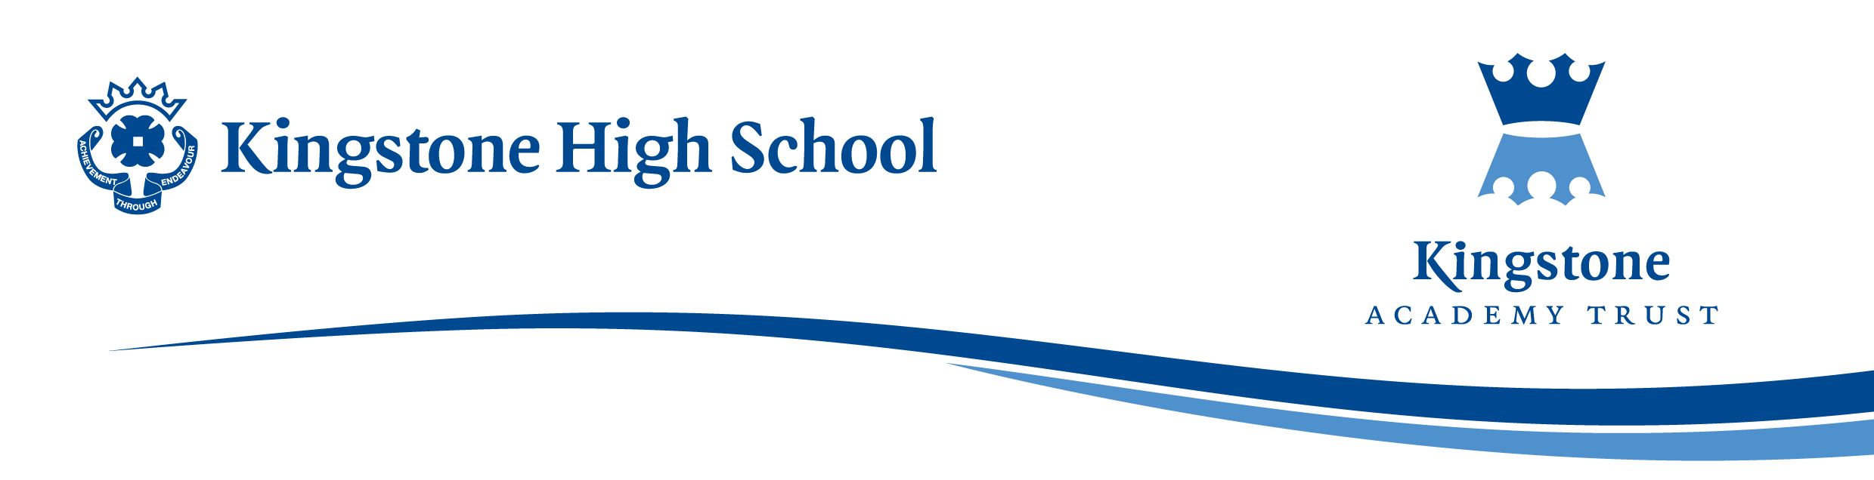

Friday 25 September 2026
Dear Parent / Carer,

The English Department would like to invite Aspire students with excellent behaviour to attend an educational trip to Warwick Castle and Royal Shakespeare Theatre, Stratford-upon-Avon on Thursday 10 December 2026. Tickets have been provisionally booked at a cost of £60.00.

Trip Itinerary

Warwick Castle

- Warwick Castle Tour
- Warwick Castle workshop
- Ice Skating
- Warwick Dungeons
- Wild Birds of Prey Show

RSC
- The Three Musketeers theatre
It is 1625, or twenty-five past four.
When the innocent D’Artagnan sets off to Paris to become a Musketeer, a life of danger, romance and anarchy lies ahead. Young King Louis XIII’s loose grip on power and his marriage is a delicious opportunity for the dastardly Cardinal Richelieu and mysterious Milady.
Landing in the centre of this cut-throat world, D’Artagnan races through the streets and the battlefields on the trail of his abducted sweetheart Constance, fighting for honour and dodging the target on his back. But whenever strife is near, his new pals appear: The Three Musketeers. ‘One for all, and all for one!’
The departure time will be at 09:00am with the return time being around 12:30am on Friday morning. Students will need to make personal travel arrangements to accommodate both the departure and the return time at Kingstone High School.
Please be aware that all students are expected to attend school on Friday 11 December at the normal school time of 08:50am. Any absences on Friday will be logged as unauthorised.

Excellent behaviour is paramount as both venues expect all students to behave to high standards. All students attending the trip must therefore have zero negatives from the date of this letter (25 September) to the date of the trip (10 December). Any student who has applied for the trip and thereafter gains a negative consequence for any reason will automatically be removed from the trip. A full refund of monies paid will be made accordingly.

It is advised that students bring a packed lunch and/or dinner and a range of snacks for the day. It is possible to purchase food at the restaurants at Warwick Castle and there will be various food stalls, but please be aware that these could prove to be expensive for both lunch and dinner.

Both Warwick Castle and the RSC are cashless, so it is essential that all students have a payment card for any purchase transactions. If anyone does not have a card, they will need to bring lunch/dinner and snacks for the duration of the day.
The Finance Department has kindly offered payment to either be in full (£60.00) or in three monthly payments. As this is expected to be a popular trip, students will be automatically removed if a payment date is not made and another student be allocated the seat. A refund will be given for any monies paid.
- To secure a seat, an initial payment of £20.00 (or full payment £60.00) should be made on ParentPay by 15:30pm on Wednesday, 30 September 2026.
- The second payment of £20.00 to be made on ParentPay by 15:30pm on Friday, 30 October 2026.
- The third and final payment of £20.00 to made on ParentPay by 15:30pm on Monday, 30 November 2026.
Any Free School Meal or Pupil Premium students could be offered trip financial support in September 2026. Please contact Mrs Chalk, Finance Office on 01981 250224.

It is important to note that once the application is made and accepted, there will be no refunds unless another suitable student can be found for the trip. In addition, if a student changes their mind or is absent for any reason on the day of the trip, a refund will not be issued.

The closing date for application is Friday 16 October 2026.

Kind regards

Miss Reeves
Trip Leader
sreeves@kingstoneacademy.co.uk

