**How to Log in to Outlook 365**

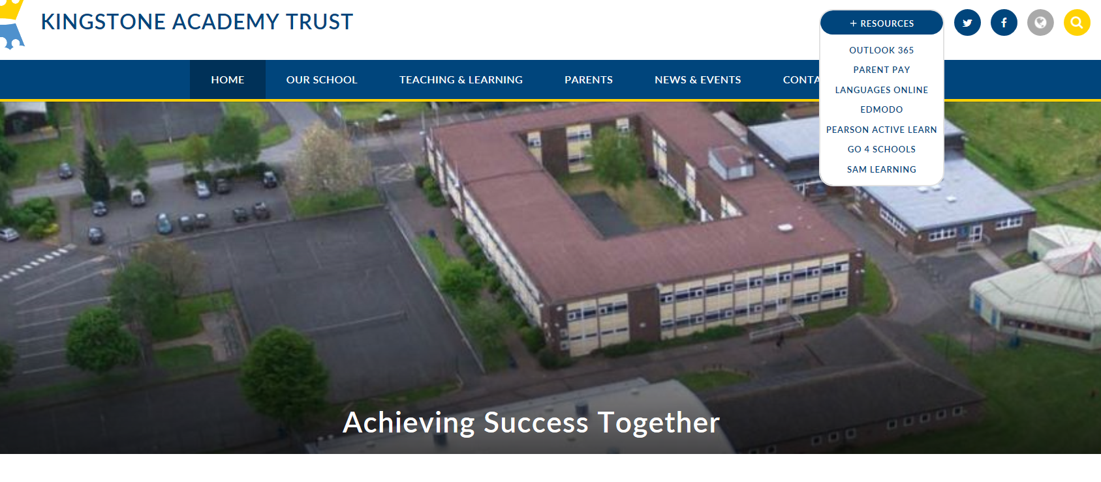Outlook 365 is accessible on the Kingstone Academy Trust school website as shown below. At thetop of the page on the right hand side you will see an icon called **RESOURCES.** You can also google Outlook 365

Click onto OUTLOOK 365 where it will load a separate page as shown below. Once the page has loaded, click onto **SIGN IN**

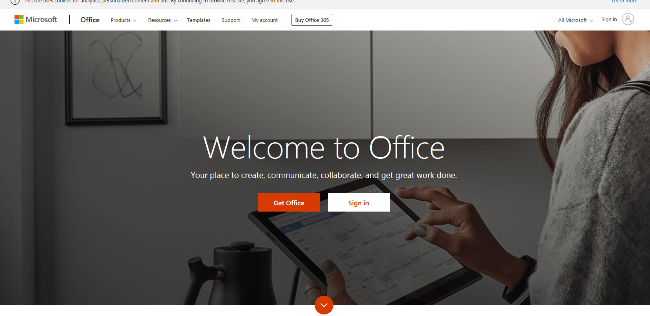

Once you have clicked onto sign in, you will then be required to input your school email address as below.

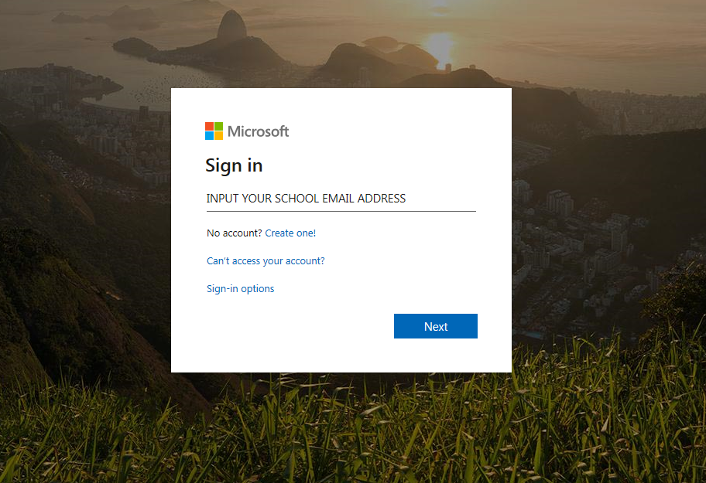

**Your school email address will be the same log in and password in which you use to log on to the system in school**. This will be your first initial, surname, year you are due to leave school and followed by ‘@kingstoneacademy.co.uk’. Please see example below.

[BSmith23@kingstoneacademy.co.uk](mailto:BSmith23@kingstoneacademy.co.uk)

Your password will be the same password in which you use to log onto your account in school. If you cannot remember your password this can be reset by any member of staff.

Once logged onto Office 365 you will have free access to Microsoft Office such as; Word, Excel, and Publisher to complete your work.

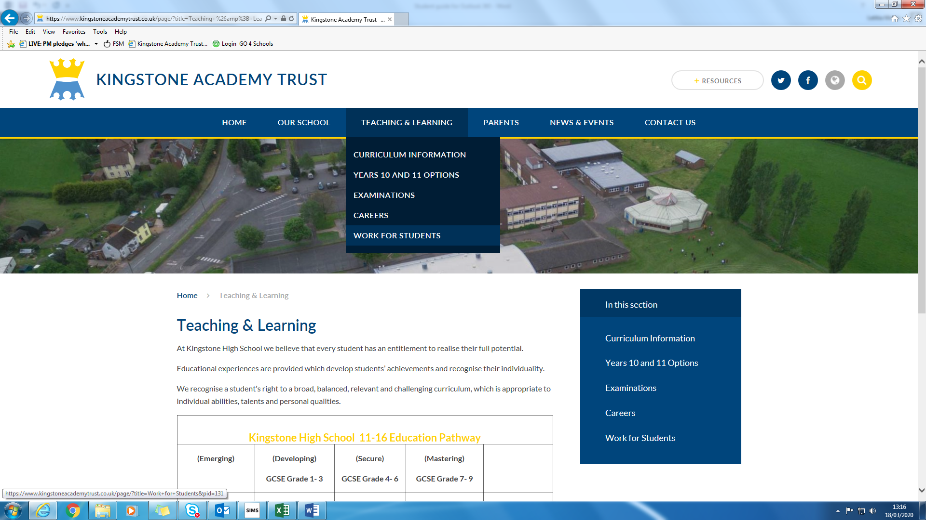To access work which has been set per subject please see instructions below;

Firstly, click onto **Teaching & Learning** on the top bar and you will see a drop down section. Once you see the drop down section please click on;

**Work for Students**

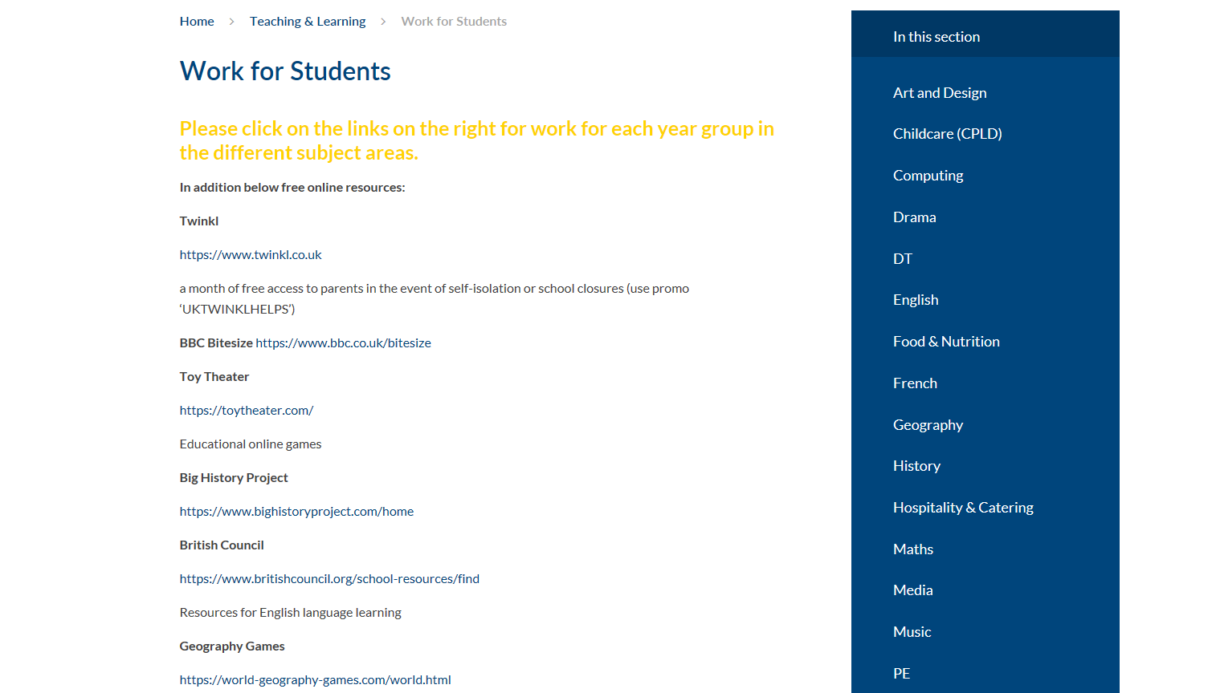Below will show the screen you should see which lists each subject and any work which has been set for your particular subject and year group.