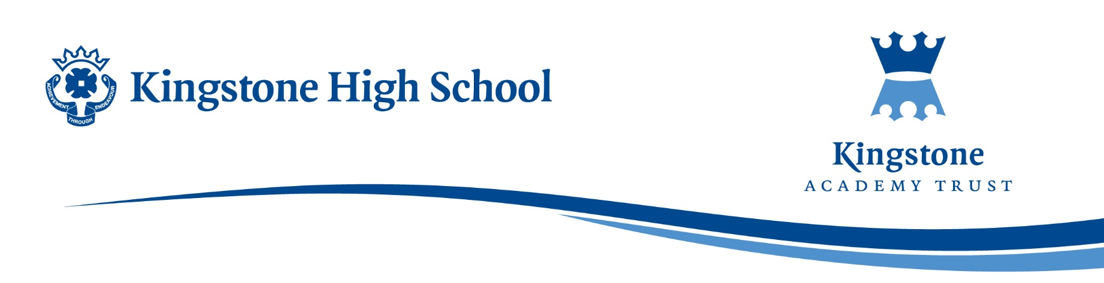

September 2025

Dear Parent/Guardian,

Re: Purchase of Revision Guides for Combined Science

We hope this letter finds you well. As part of our ongoing support for your child’s education, we are pleased to offer the opportunity to purchase a revision guide and workbook for science to aid in their preparation for upcoming exams.

These resources have been carefully selected to complement the curriculum and help your child consolidate their learning. If you would like to purchase a copy of the revision guide and workbook, please follow the steps below:

- Cost: The price for the revision guide and workbook is £10.49 for higher tier and £10.24 for foundation tier. If your child is in receipt of free school meals a revision guide and workbook will be provided for them.
- Order Process: To purchase a guide, please use your ParentPay account to place the order.
- Deadline: Orders must be submitted by 1st October to ensure delivery before the mock exams.
If you have any questions or need further information, please don’t hesitate to contact me by email at SWilson@kingstoneacademy.co.uk

We encourage all students to make the most of these resources, as they can be a valuable tool in supporting their revision.

Thank you for your continued support.

Kind regards,

Miss S Wilson

Head of Science.

