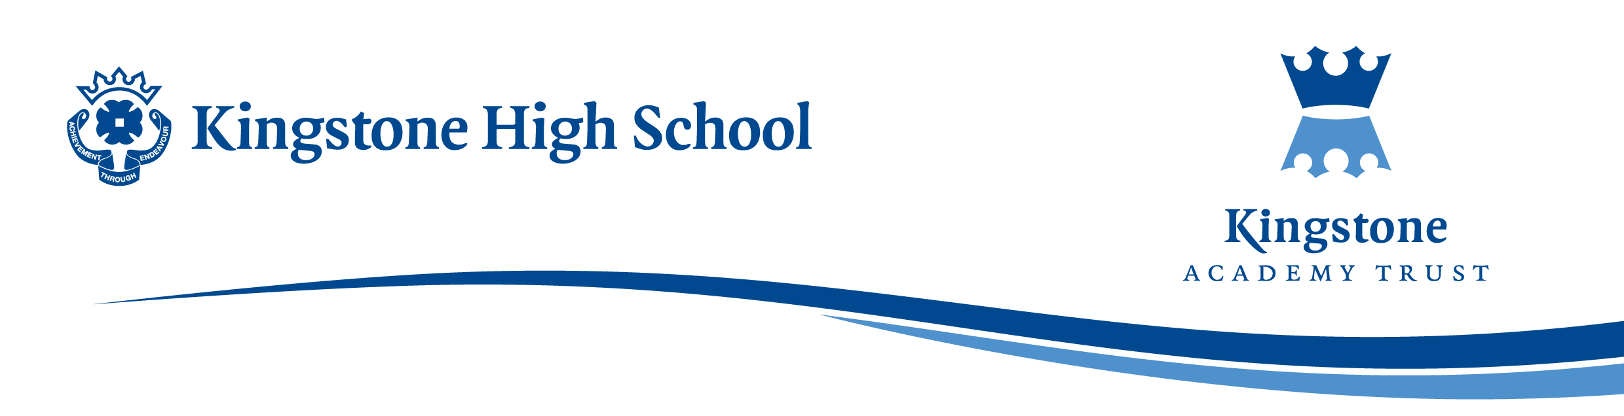

Aspire group visit to Royal Electrical and Mechanical Engineers Museum

Dear Parents and Carers,

As part of our Aspire programme we are running a trip to the Royal Electrical and Mechanical engineers Museum in Lyneham for certain students in year 8 and 9.

The aim of the trip is to highlight the value of STEM skills as valuable, adaptable life skills. It will also give them an insight into what the Royal Engineers do.
Students will have a tour of the museum and then take part in an engineering workshop, where they will be challenged to design, build and test a motorised Lego vehicle. Following this there will be another workshop on cracking codes, involving the use of Morse code.

The trip is planned for Thursday 25th September, leaving school at 8:00am and returning by 4:15- 4:30pm. The cost of the trip is £23 per student, this includes coach travel and entrance fees and all workshops at REME. Places are limited so please sign up quickly if you would like to take part.

If your son/daughter would like to attend, please complete the reply slip and return to Mrs Jones in M31. All payments for the visit will need to be made via ParentPay by Friday 5th September.

Any questions please do not hesitate to contact me via email:
ajones@kingstoneacademy.co.uk
Yours sincerely

Mrs A Jones
………………………………………………………………………………………………..

I would like / I would not like my child
Name: ……………………………….………………………… Form Group: …….……
to participate in the ASPIRE trip to REME Lyneham on Thursday 25th Sep 2025.

Does your child have any medical requirements or conditions we need to be aware of?

Yes / No If Yes, please provide details: ……………………………………………….

…………………………………………………………………………………………………

