

9 March 2026
Dear Parents and Carers,
We are pleased to inform you that the Year 10 Options process is now open.
Students have been sent an email containing a personalised link and WebCode. An example is below.
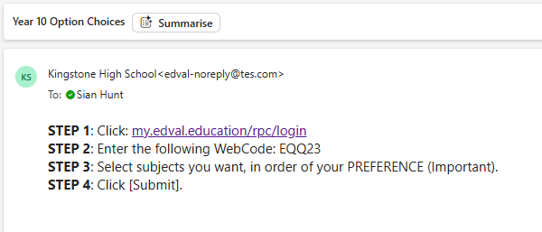
They will need to follow this link and complete the options form online. An example of the options below is below.
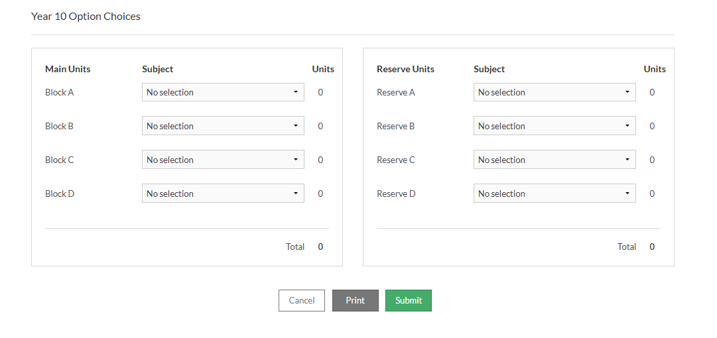

As part of the process, students are required to make one main choice and one reserve choice in each of the option blocks (A–D). Please ensure that your child takes time to consider their selections carefully and completes all sections fully before submitting. Make sure to click the submit button before leaving the page.
The options form will remain open until Monday 16th March, after which submissions will close.
We would also like to remind you of our Year 9 Parents’ Evening on Thursday 12th March, where you will have the opportunity to discuss subjects in more detail with teaching staff before final choices are made.
If you have any questions about the options process, please encourage your child to speak with their form tutor, Mr Bromage, or Mr Holmyard.
Thank you for your support.
Kind regards,
Alex Holmyard
Assistant Headteacher
Teaching and Learning

