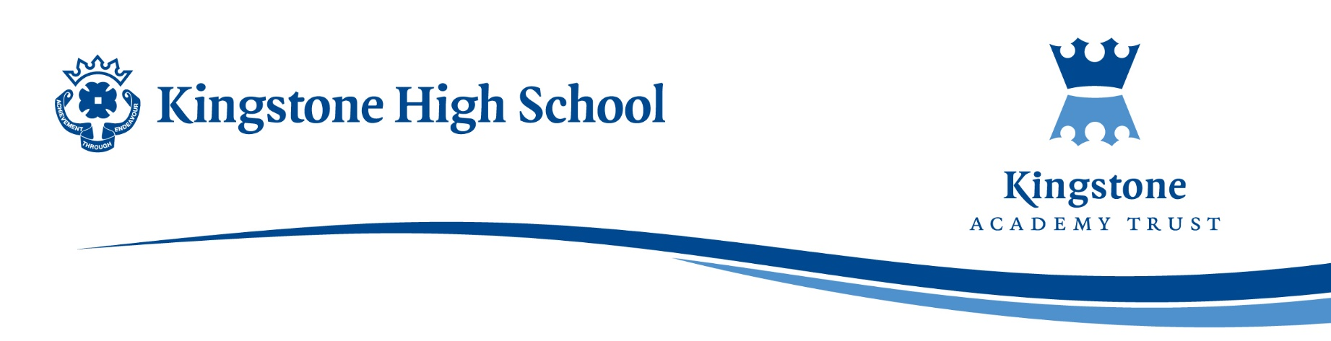

28 March 2025

Dear Parent / Carer,

Next half term, students in Year 9 will begin their transition from KS3 students of English to GCSE. Students will formally start the study of GCSE Literature by introducing a set text that they will be examined on in Year 11 (May 2027 - exact dates to follow).

As this is the beginning of their GCSE English journey, studying GCSE English Language alongside GCSE English Literature over two years, we want to ensure that Year 9 are familiar and comfortable with the plot and characters from a GCSE English Literature text, before they leave for the Summer holidays.

Following the success of offering students the opportunity to buy copies of these texts in previous years, we will again be making texts available. This then gives students the freedom to annotate their own personal copies of the texts, which will form the basis of the student's revision.

I know this is a difficult time for many and, as such, we have bulk ordered all of the set texts required allowing us to offer them to you at the price of just £9.10. I strongly advise students to have their own copies for ease of study and have found this to be an investment in student outcomes in the past.

If you have any concerns about the cost, please do not hesitate to contact the Finance Office. Otherwise, payment can be made via Parent Pay by **Friday, 11th April 2025.**

Finally, can I take this opportunity to thank you for your ongoing support. Please do contact me if you have any questions.

Yours faithfully

*L. A. Powell*

Mrs L Powell

Head of English and Media