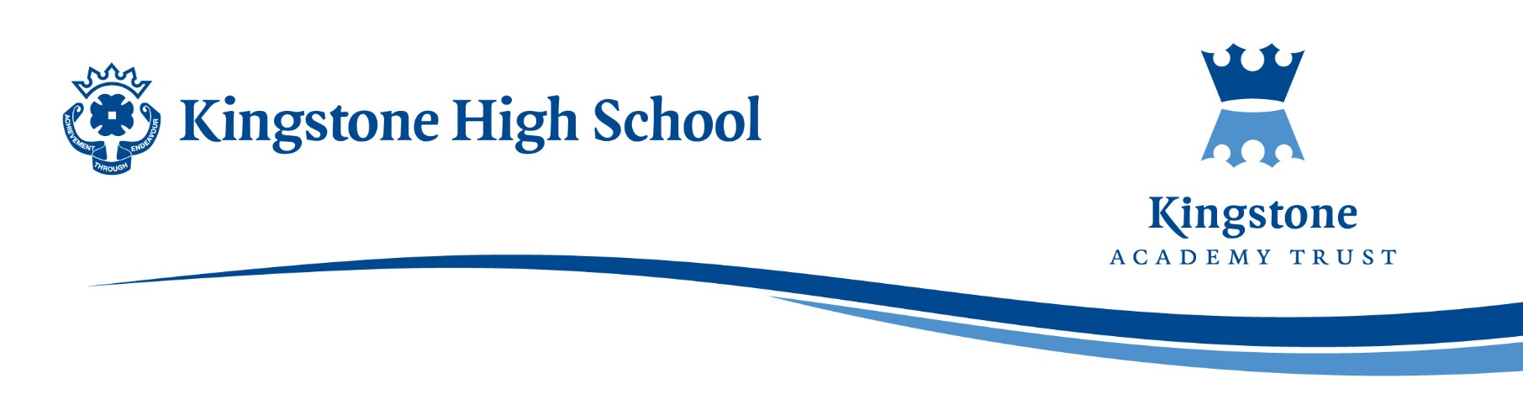

Dear Parents and Carers,
I am writing to inform you that Key Assessment 3 will take place from Monday 22nd June to Friday 3rd July.
These assessments are a very important part of the academic year, as they provide students with an opportunity to demonstrate the knowledge and skills they have developed across their subjects. The results will help inform future learning, support teachers in planning, and give a clear picture of each student’s progress at the end of the year. As such, we strongly encourage all students to approach these assessments with diligence and commitment.
To support students in their preparation, a series of assemblies have already been delivered focusing on revision strategies, organisation, and effective study habits. Additional assemblies and guidance sessions will continue to take place in the coming weeks to further support students in preparing confidently.
We will also be sending out a revision booklet, which will clearly outline the content that students need to revise for each subject. We encourage you to review this with your child and help them plan a structured revision timetable at home.
A detailed examination timetable specifying the dates and times of each subject assessment will be shared closer to the assessment period.
Thank you for your continued support in helping your child prepare for these important assessments. If you have any questions, please do not hesitate to contact the school.
Yours sincerely,
Alex Holmyard
Assistant Headteacher – Quality of Education

