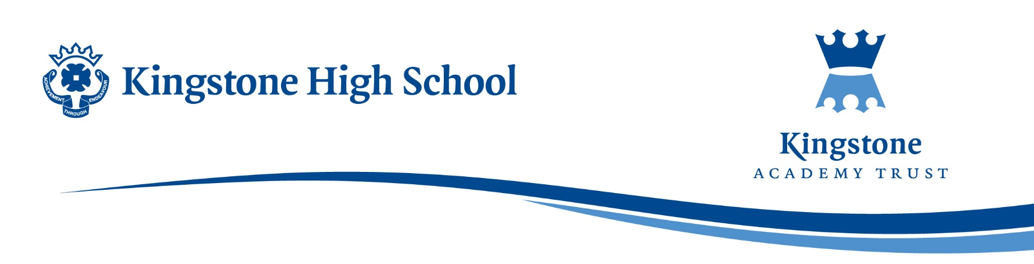

Wednesday, 26 November 2025
Dear Parent/Carer,
The English Department is delighted to announce that the HPW/RSC trip is to take place on Thursday, 04 December 2025. As you have accepted an invitation for a student to attend this trip, would you please read the below details and the accompanying trip information sheet.
Itinerary
- Harry Potter World workshop
- Harry Potter World tour
- Royal Shakespeare Company – The Big Friendly Giant
Students are asked to bring a packed lunch / packed dinner if required and a range of snacks for the day.
As mentioned in an earlier letter, the RSC is cashless, so it is essential that all students have a payment card for any purchase transactions at this venue.
Please read the accompanying trip information sheet for further trip details.
If you have any further queries or concerns, please contact
sreeves@kingstoneacademy.co.uk.
We are sure that this will be a wonderful trip for all concerned,
Kind regards
Miss Reeves
London Trip Leader

